**DATA ANALYST**

**COFFEE SHOP SALES PROJECT**

**USING MYSQL**

**COUNT OF DATABASE**

SELECT COUNT (*) FROM coffee_shop_sales;

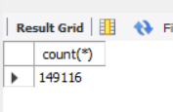

**CHANGE COLUMN NAME `ï»¿transaction_id` to transaction_id**

ALTER TABLE coffee_shop_sales

CHANGE COLUMN ï»¿transaction_id transaction_id INT PRIMARY KEY;

**CONVERT COLUMN TO DATE DATA TYPE**

ALTER TABLE coffee_shop_sales

MODIFY COLUMN transaction_date DATE;

**CONVERT COLUMN TO TIME DATA TYPE**

ALTER TABLE coffee_shop_sales

MODIFY COLUMN transaction_time TIME;

**DATA TYPES OF DIFFERENT COLUMNS**

DESCRIBE coffee_shop_sales;

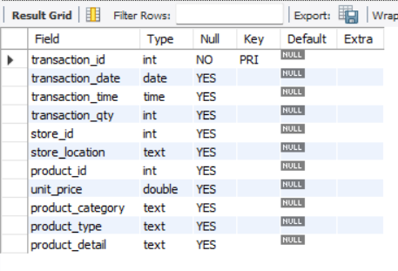

**TOTAL SALES**

SELECT ROUND(SUM(unit_price*transaction_qty)) as Total_Sales

FROM coffee_shop_sales;

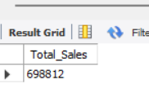

**TOTAL SALES - MONTH TO MONTH DIFFERENCE AND MONTH TO MONTH GROWTH**

SELECT month(transaction_date) as month,

ROUND(SUM(unit_price*transaction_qty)) as Total_Sales,

(SUM(unit_price * transaction_qty) - LAG(SUM(unit_price * transaction_qty))

OVER (ORDER BY MONTH(transaction_date))) / LAG(SUM(unit_price * transaction_qty))

OVER (ORDER BY MONTH(transaction_date)) * 100 AS mom_increase_percentage

FROM coffee_shop_sales

GROUP BY MONTH(transaction_date);

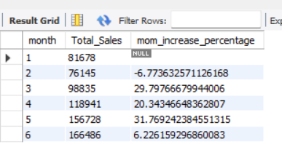

Note : Month-[1-Jan , 2-Feb , 3-Mar , 4-April, 5-May, 6-June]

**TOTAL SOLD QUANTITY**

SELECT COUNT(transaction_qty) as Total_Sold_Quantity

FROM coffee_shop_sales;

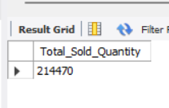

**TOTAL SOLD QUANTITY – MONTH TO MONTH DIFFERENCE AND MONTH TO MONTH GROWTH**

SELECT

MONTH(transaction_date),

SUM(transaction_qty) as Total_Sold_Quantity,

(SUM(transaction_qty) - LAG(sum(transaction_qty))

OVER (ORDER BY MONTH(transaction_date))) / LAG(sum(transaction_qty))

OVER (ORDER BY MONTH(transaction_date)) * 100 AS mom_increase_percentage

FROM coffee_shop_sales

GROUP BY MONTH(transaction_date);

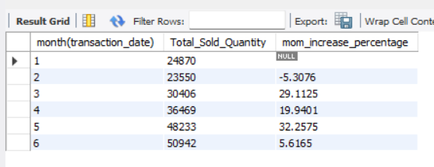

Note: Month-[1-Jan , 2-Feb , 3-Mar , 4-April, 5-May, 6-June]

**TOTAL ORDERS**

SELECT COUNT(transaction_id) as Total_Orders

FROM coffee_shop_sales ;

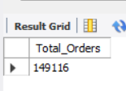

**TOTAL SOLD QUANTITY – MONTH TO MONTH DIFFERENCE AND MONTH TO MONTH GROWTH**

SELECT    MONTH(transaction_date) AS month,

COUNT(transaction_id) AS Total_Orders,

(COUNT(transaction_id) - LAG(COUNT(transaction_id))

OVER (ORDER BY MONTH(transaction_date))) / lag(COUNT(transaction_qty))

OVER (ORDER BY MONTH(transaction_date)) * 100 AS mom_increase_percentage

FROM coffee_shop_sales

GROUP BY MONTH(transaction_date);

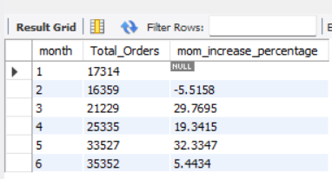

Note : Month-[1-Jan , 2-Feb , 3-Mar , 4-April, 5-May, 6-June]

**DAILY SALES FOR MONTH SELECTED**

SELECT DAY(transaction_date) AS days,

ROUND(SUM(unit_price * transaction_qty),1) AS total_sales

FROM coffee_shop_sales

WHERE MONTH(transaction_date) = 6 -- Filter for June

GROUP BY DAY(transaction_date)

ORDER BY DAY(transaction_date);

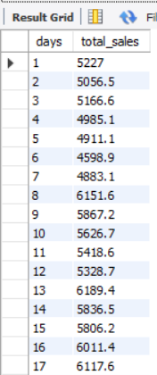 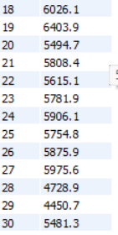

**SALES BY WEEKDAY / WEEKEND:**

SELECT CASE

WHEN DAYOFWEEK(transaction_date) IN (1, 7) THEN 'Weekends'

ELSE 'Weekdays'

END AS day_type,

ROUND(SUM(unit_price * transaction_qty)) AS total_sales

FROM coffee_shop_sales

WHERE MONTH(transaction_date) = 5 -- Filter for May

GROUP BY CASE

WHEN DAYOFWEEK(transaction_date) IN (1, 7) THEN 'Weekends'

ELSE 'Weekdays'

END;

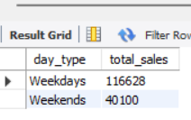

**SALES BY STORE LOCATION**

SELECT store_location,

ROUND(SUM(unit_price * transaction_qty),1) AS total_sales

FROM coffee_shop_sales

GROUP BY store_location

ORDER BY ROUND(SUM(unit_price * transaction_qty),1);

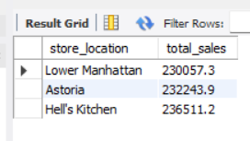

**SALES BY STORE LOCATION BY MONTH**

SELECT store_location,

ROUND(SUM(unit_price * transaction_qty),1) AS total_sales

FROM coffee_shop_sales

WHERE MONTH(transaction_date)=6 -- Filter for june

GROUP BY store_location

ORDER BY ROUND(SUM(unit_price * transaction_qty),1);

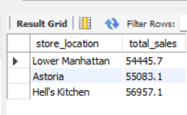

**SALES BY PRODUCT CATEGORY**

SELECT product_category,

ROUND(SUM(unit_price*transaction_qty)) AS total_sales

FROM coffee_shop_sales

GROUP BY product_category

ORDER BY ROUND(SUM(unit_price*transaction_qty)) desc;

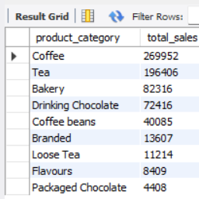

**SALES BY PRODUCT CATEGORY BY MONTH**

SELECT product_category,

ROUND(SUM(unit_price*transaction_qty)) as total_sales

FROM coffee_shop_sales

WHERE MONTH(transaction_date) = 6

GROUP BY product_category

ORDER BY ROUND(SUM(unit_price*transaction_qty)) desc;

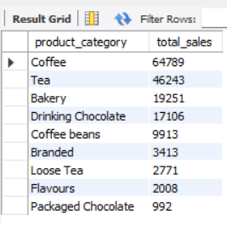

**SALES BY TOP 5 PRODUCTS**

SELECT product_type,

ROUND(SUM(unit_price*transaction_qty)) AS total_sales

FROM coffee_shop_sales

GROUP BY product_type

ORDER BY ROUND(SUM(unit_price*transaction_qty)) desc

LIMIT 5;

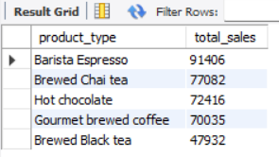

**SALES BY DAY | HOUR**

SELECT ROUND(SUM(unit_price * transaction_qty)) AS Total_Sales,

SUM(transaction_qty) AS Total_Quantity,

COUNT(transaction_id) AS Total_Orders

FROM coffee_shop_sales

WHERE MONTH(transaction_date)= 5  --Filter for May (month number 5)

AND DAYOFWEEK(transaction_date) = 3  -- Filter for Tuesday (1 is Sunday, 2 is Monday, ...7 Saturday)

AND HOUR(transaction_time)= 9; --Filter for hour number 8

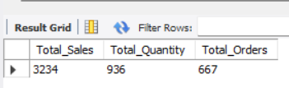

***TO GET SALES FROM MONDAY TO SUNDAY FOR MONTH OF MAY***

SELECT

CASE

WHEN DAYOFWEEK(transaction_date) =1 THEN 'Sunday'

WHEN DAYOFWEEK(transaction_date) =2 THEN 'Monday'

WHEN DAYOFWEEK(transaction_date) =3 THEN 'Tuesday'

WHEN DAYOFWEEK(transaction_date) =4 THEN 'Wednesday'

WHEN DAYOFWEEK(transaction_date) =5 THEN 'Thursday'

WHEN DAYOFWEEK(transaction_date) =6 THEN 'Friday'

ELSE 'Saturday'

END AS Day_of_Week,

ROUND(SUM(unit_price * transaction_qty)) AS Total_Sales

FROM coffee_shop_sales

WHERE MONTH(transaction_date)= 5 --Filter for May (month number 5)

GROUP BY

CASE

WHEN DAYOFWEEK(transaction_date) =1 THEN 'Sunday'

WHEN DAYOFWEEK(transaction_date) =2 THEN 'Monday'

WHEN DAYOFWEEK(transaction_date) =3 THEN 'Tuesday'

WHEN DAYOFWEEK(transaction_date) =4 THEN 'Wednesday'

WHEN DAYOFWEEK(transaction_date) =5 THEN 'Thursday'

WHEN DAYOFWEEK(transaction_date) =6 THEN 'Friday'

ELSE 'Saturday'

END;

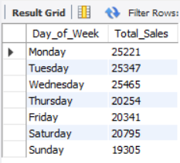

***TO GET SALES FOR ALL HOURS FOR MONTH OF MAY***

SELECT HOUR(transaction_time) AS Hour_days,

ROUND(SUM(unit_price * transaction_qty)) AS Total_Sales

FROM coffee_shop_sales

WHERE MONTH(transaction_date)=5 --Filter for May (month number 5)

GROUP BY HOUR(transaction_time)

ORDER BY HOUR(transaction_time);

